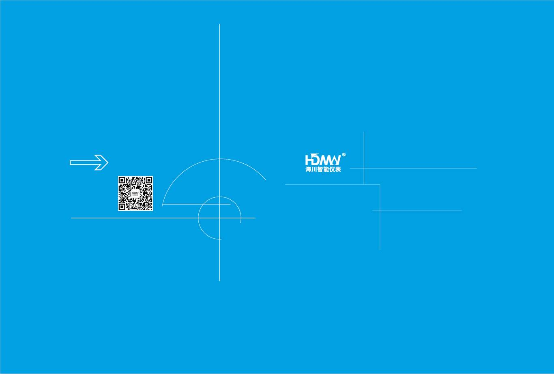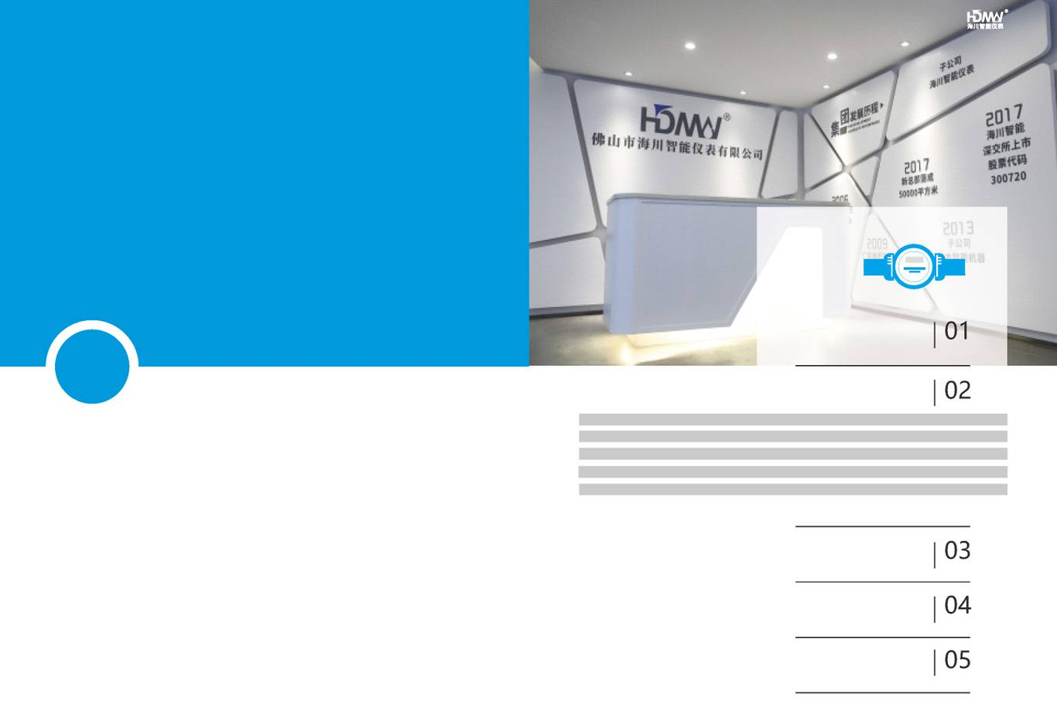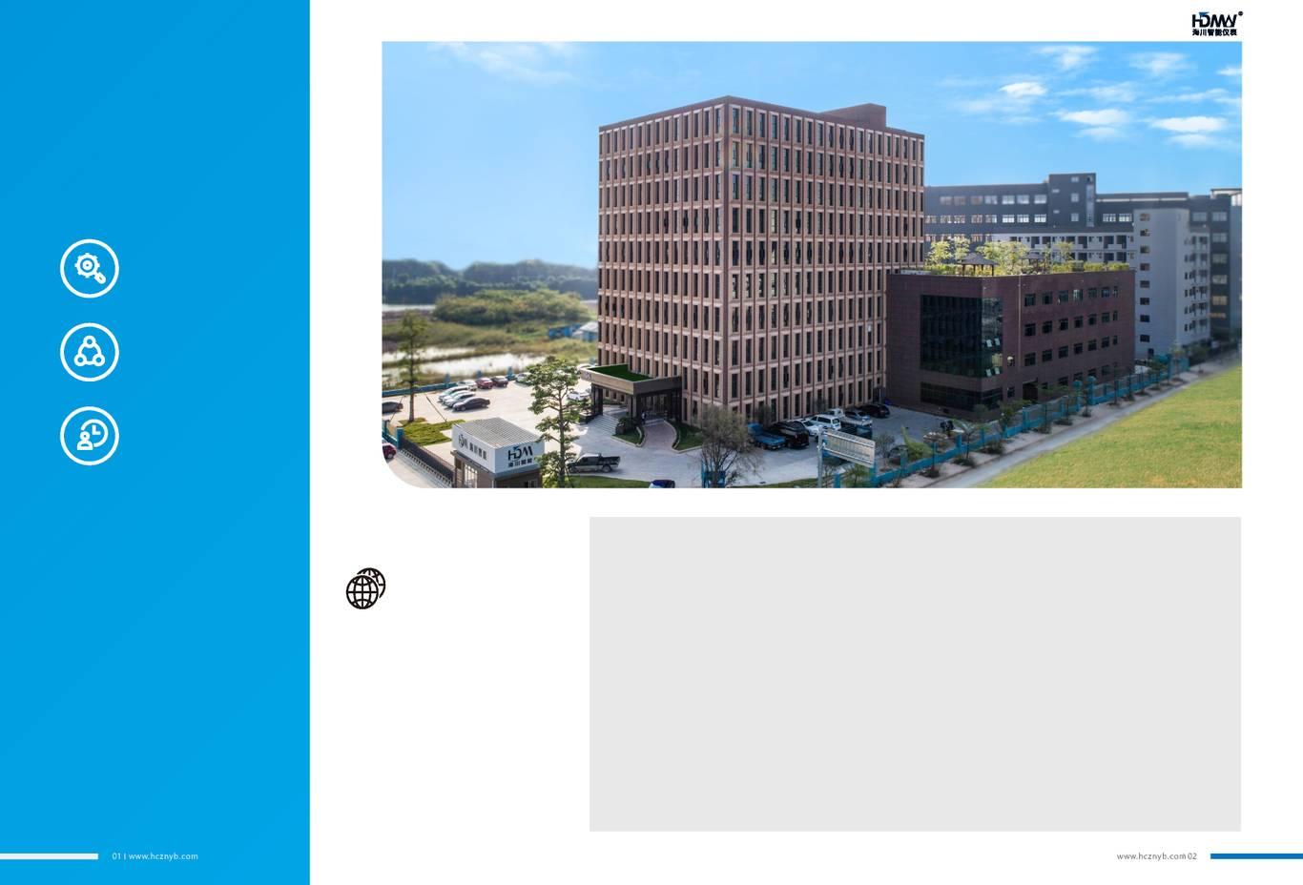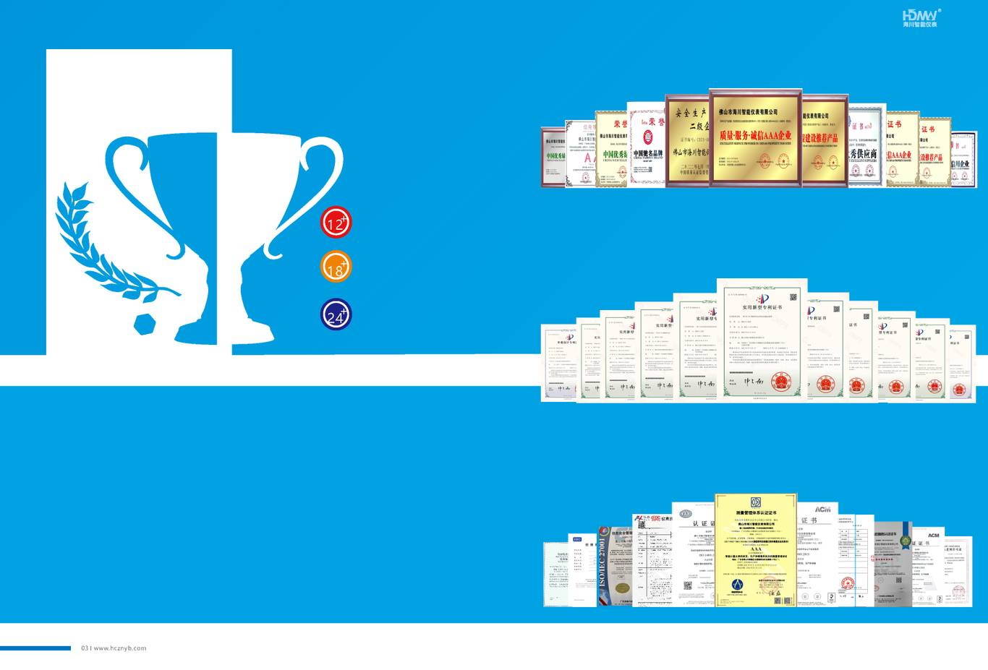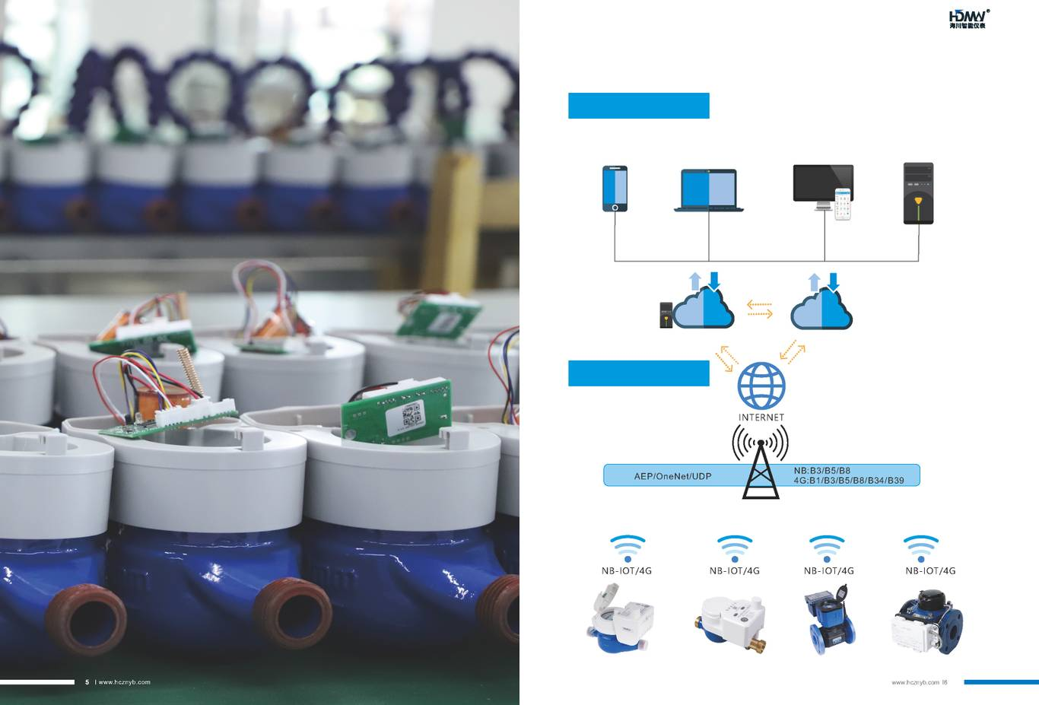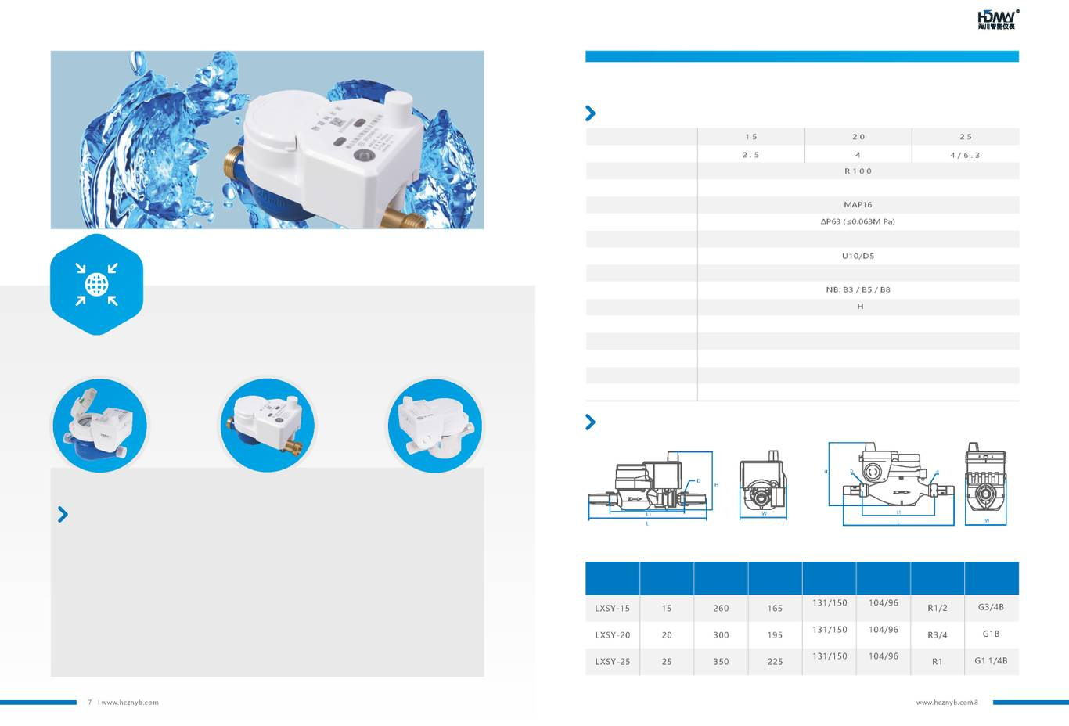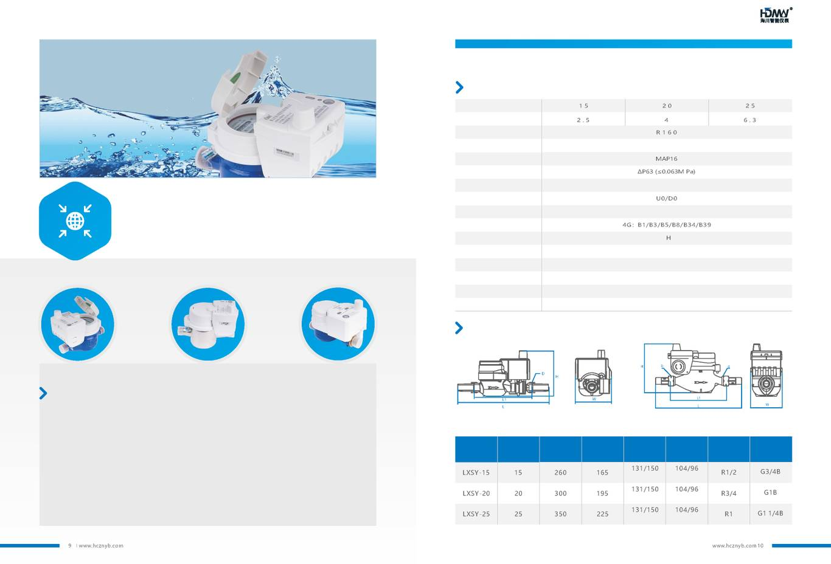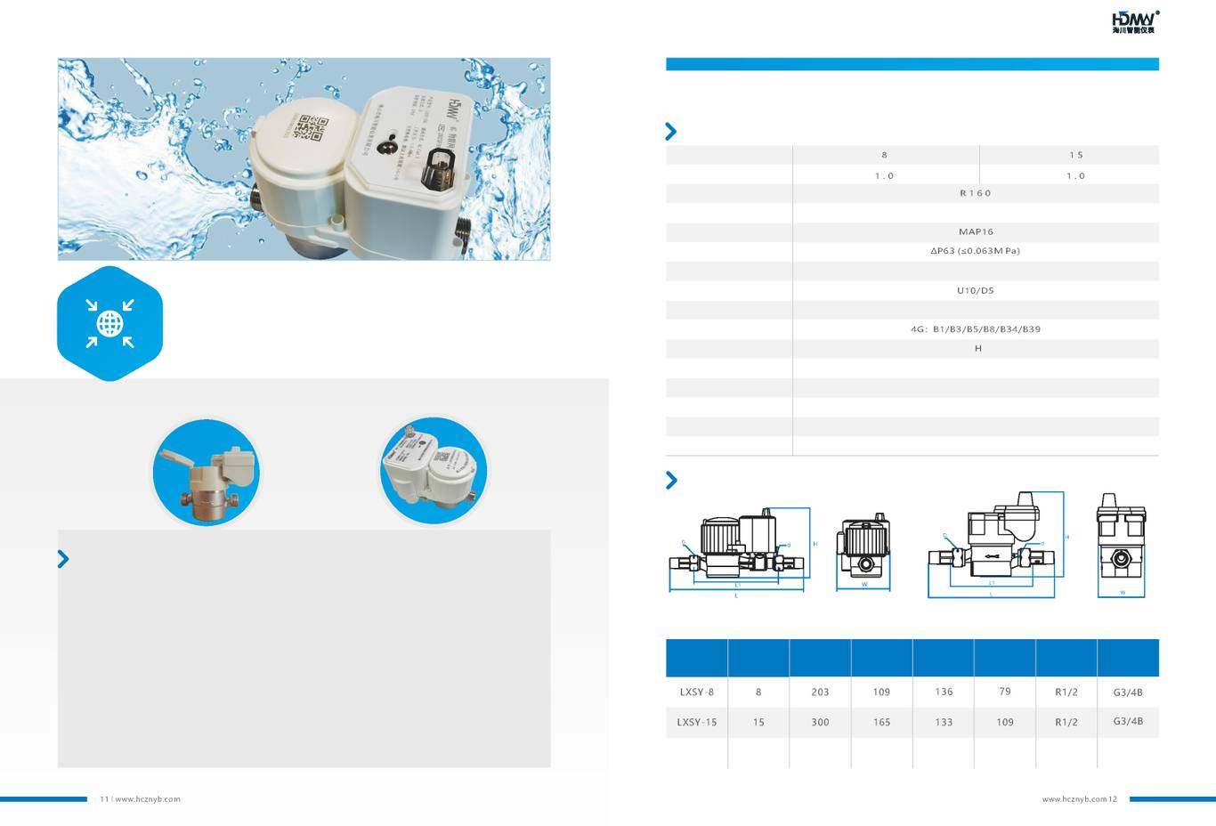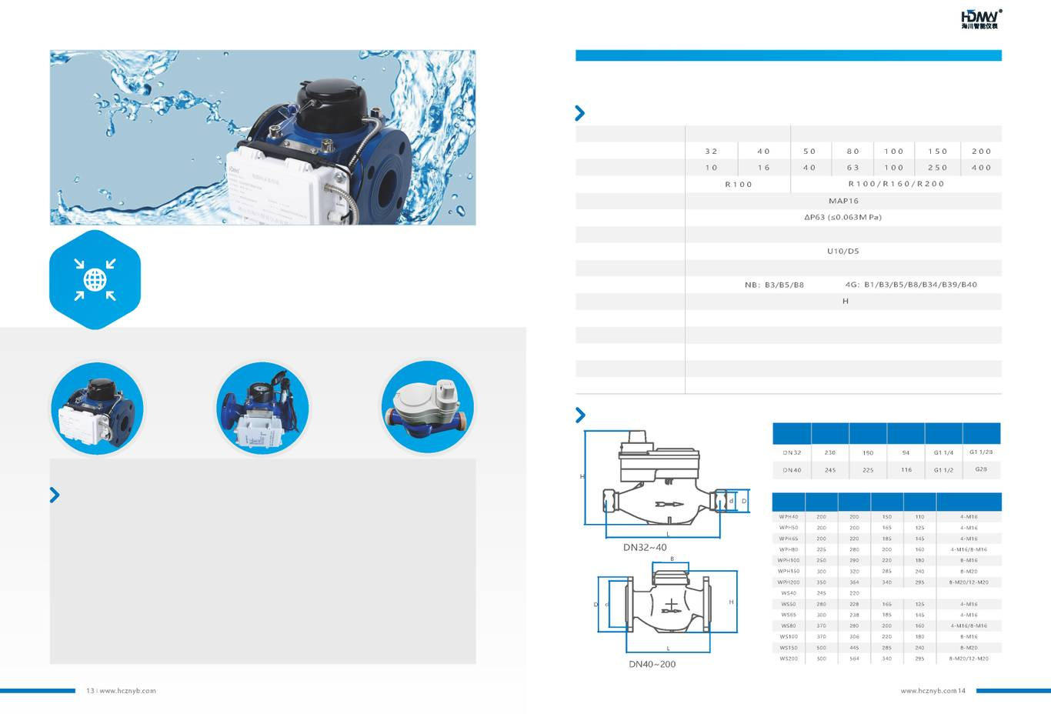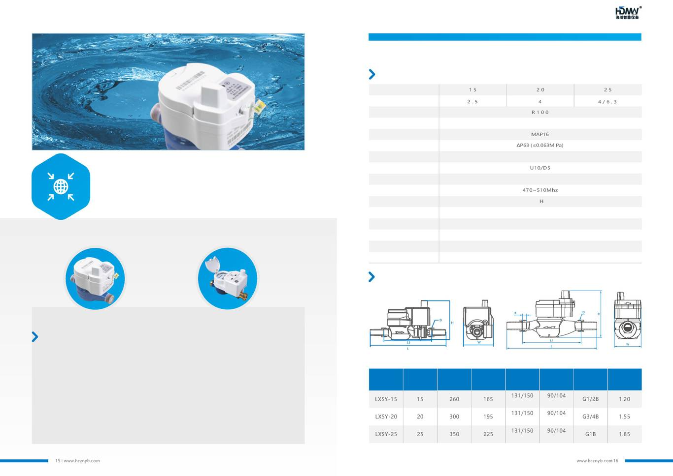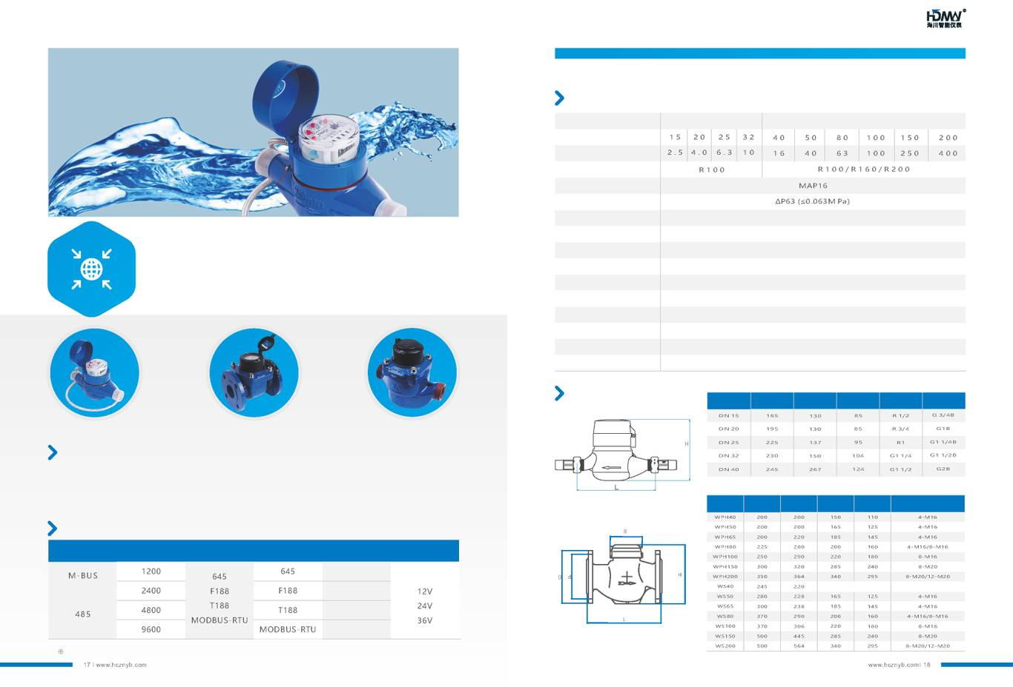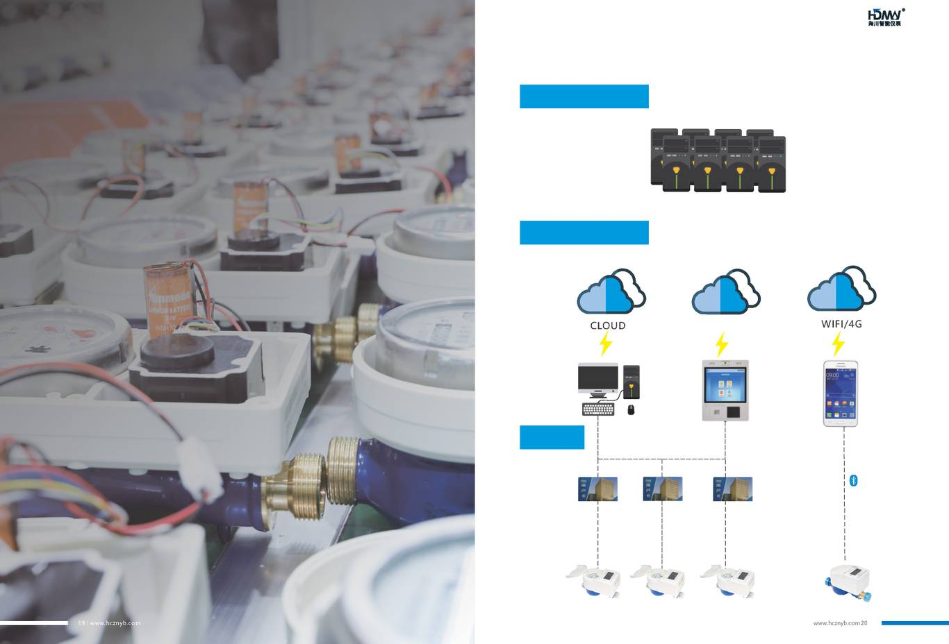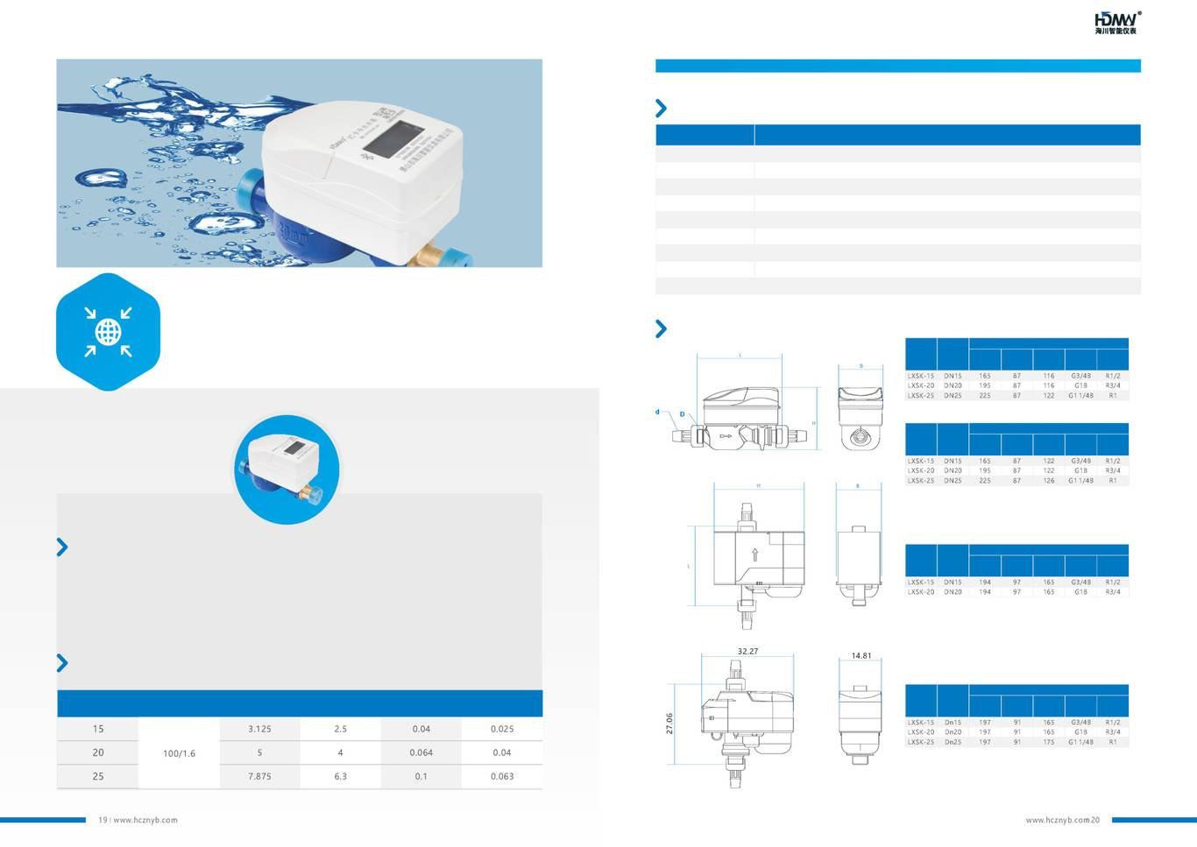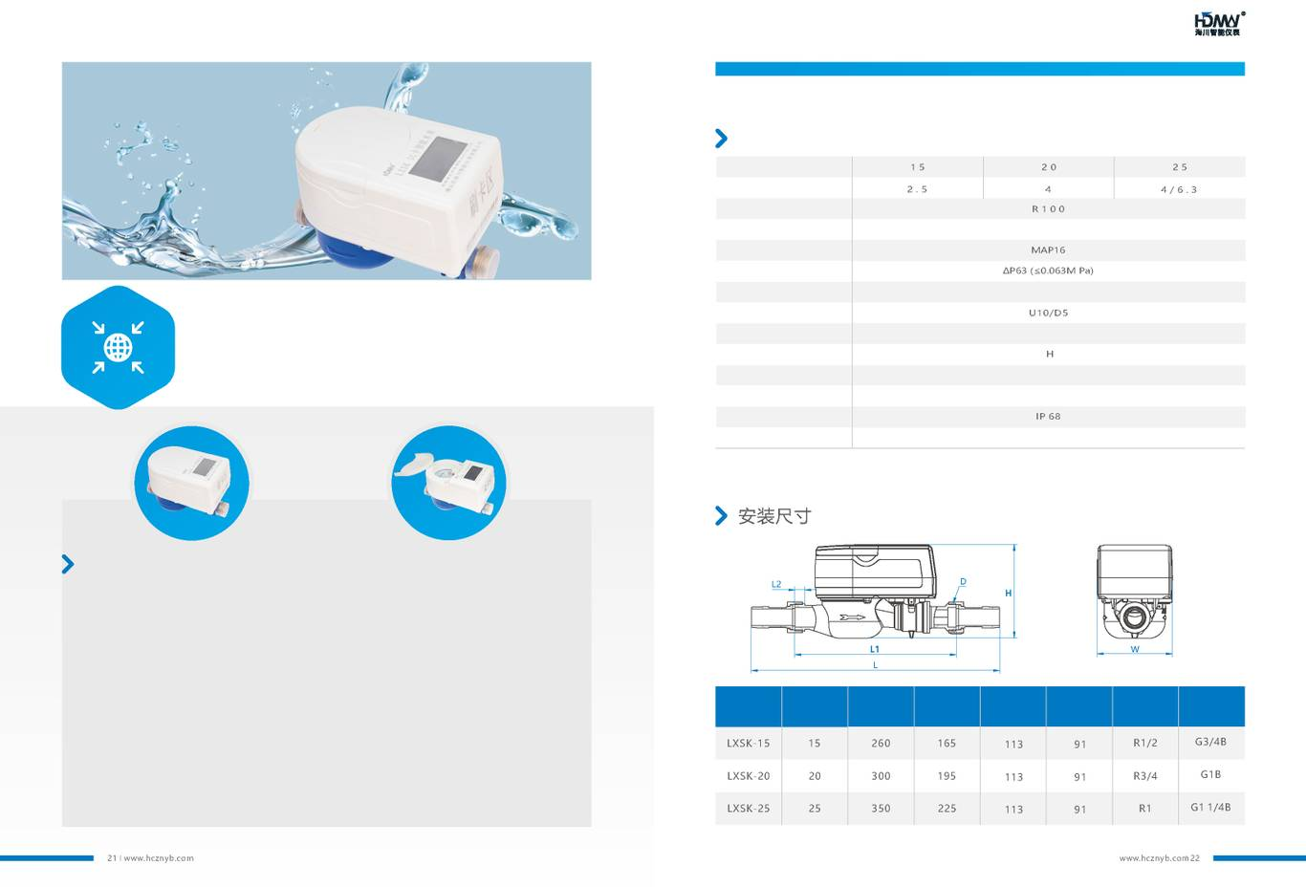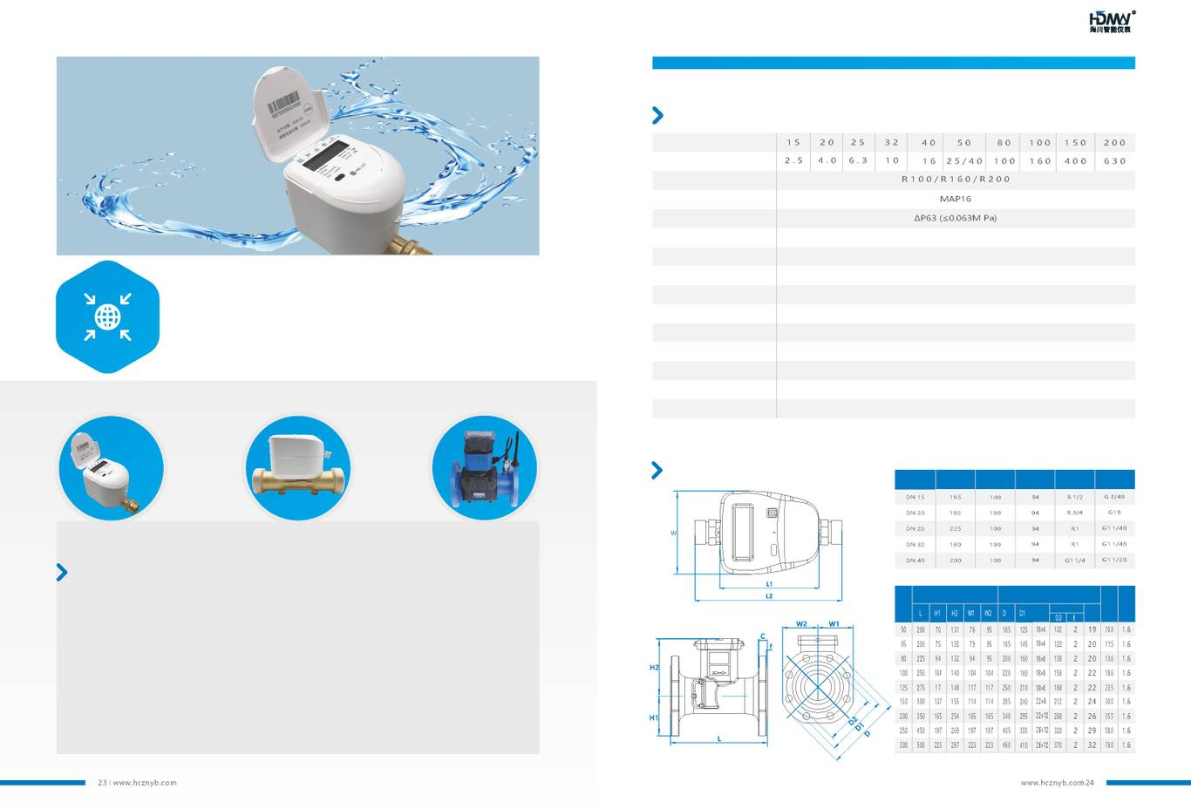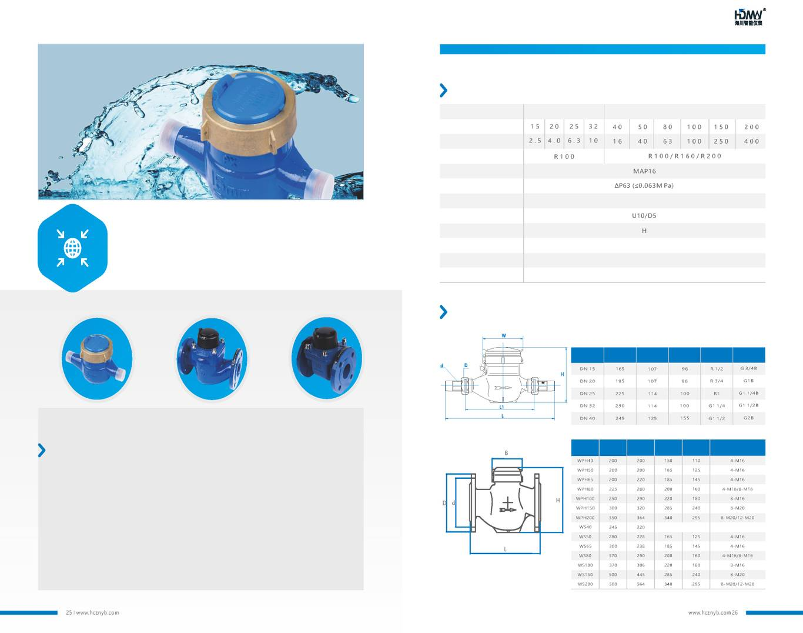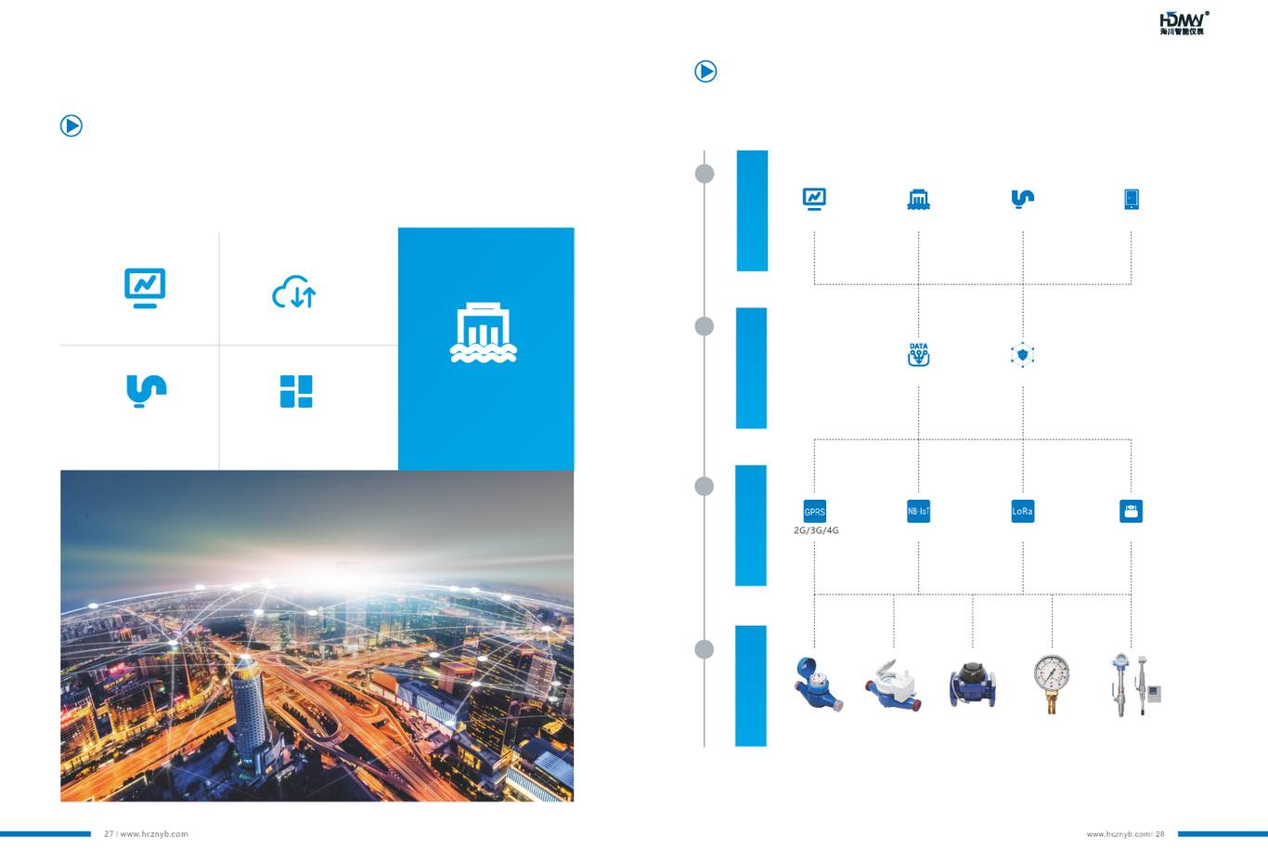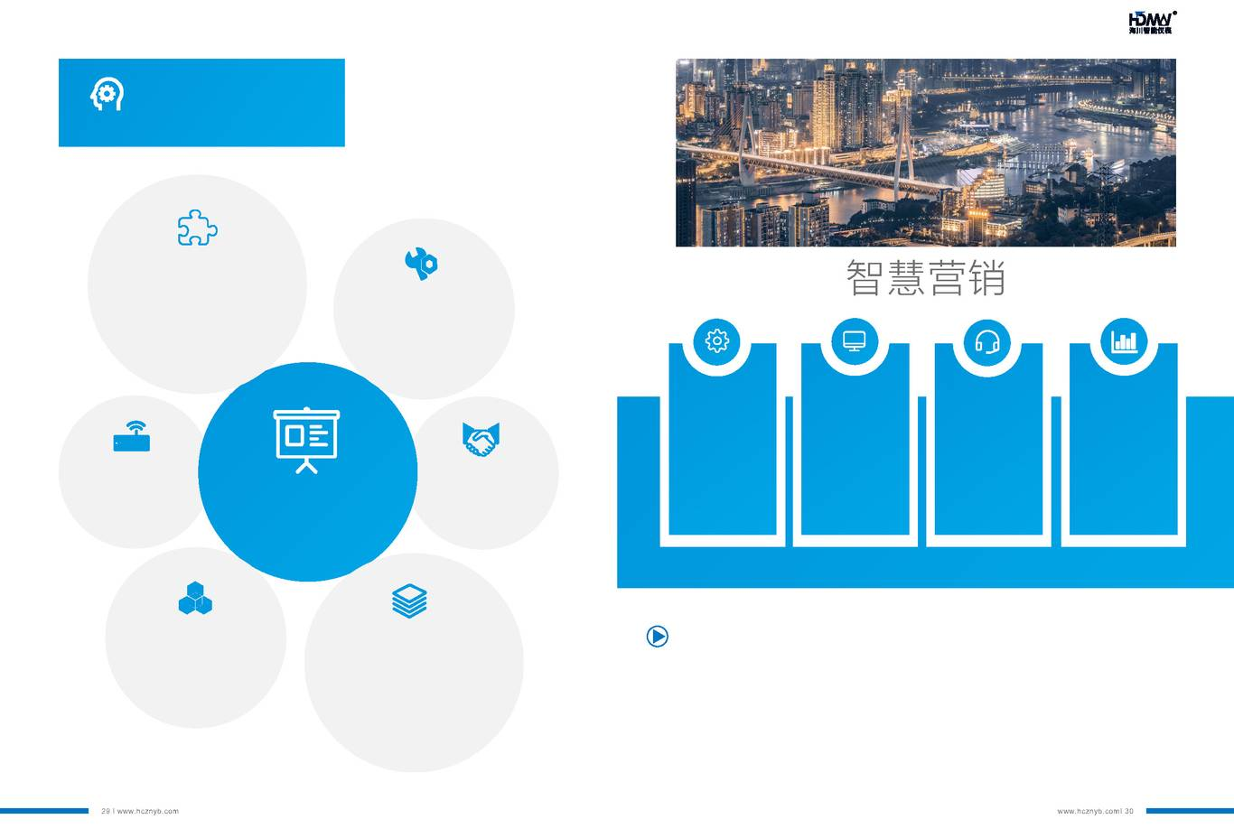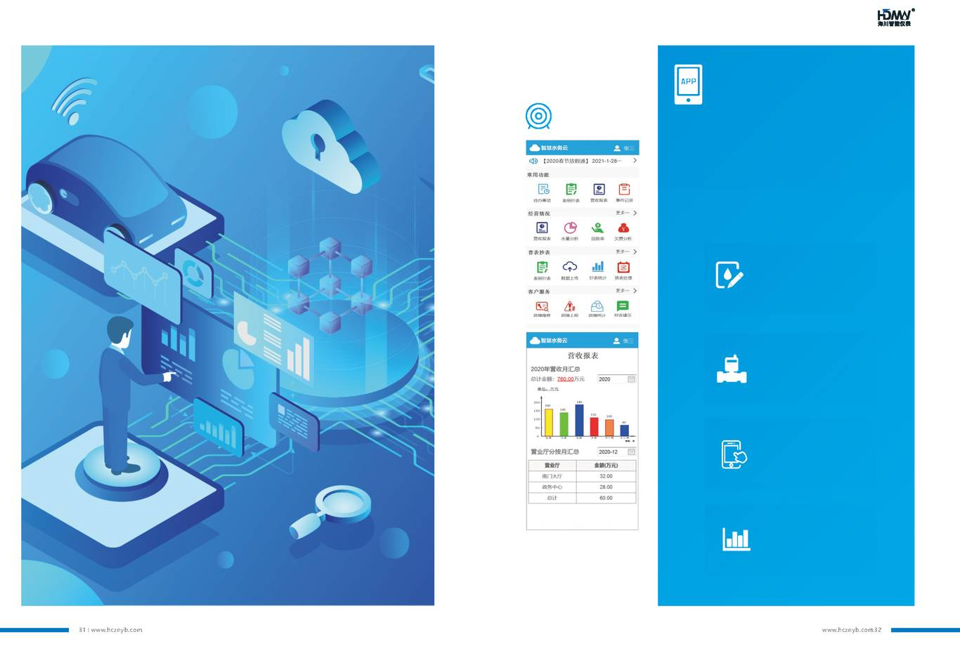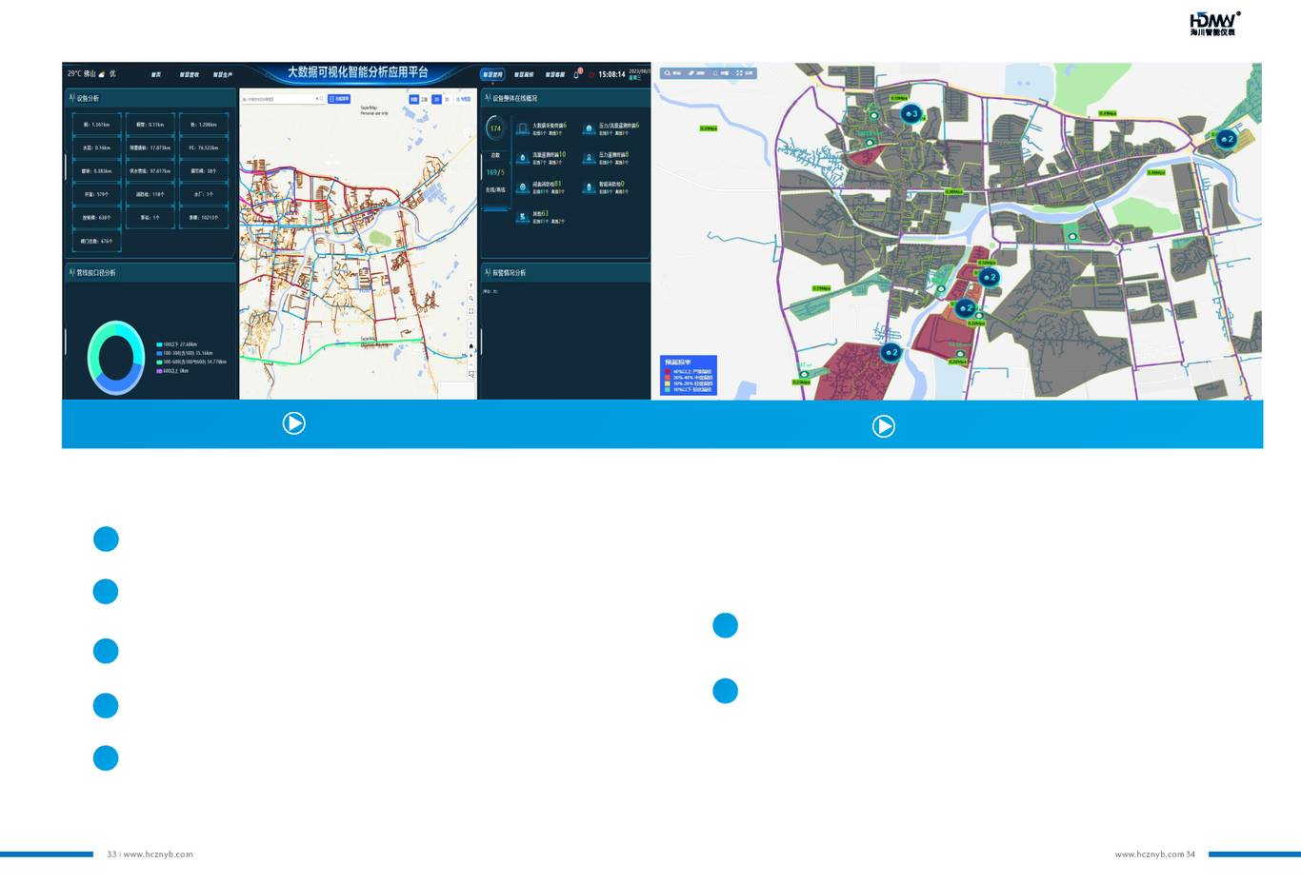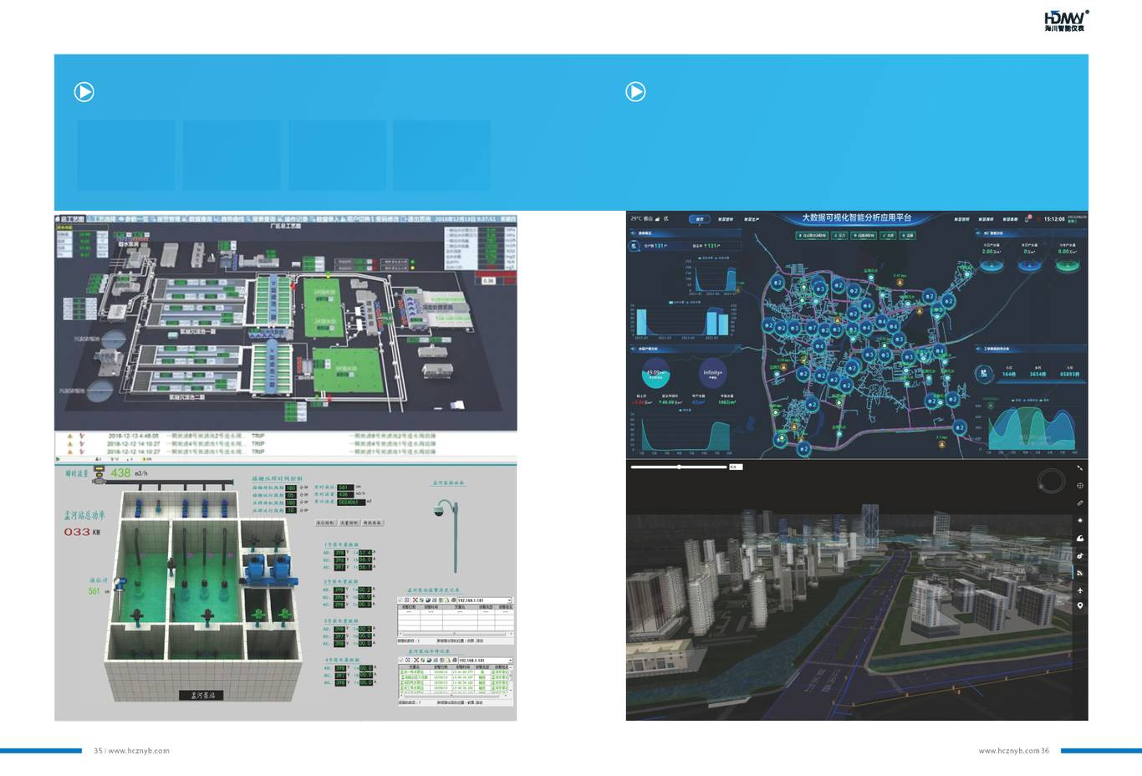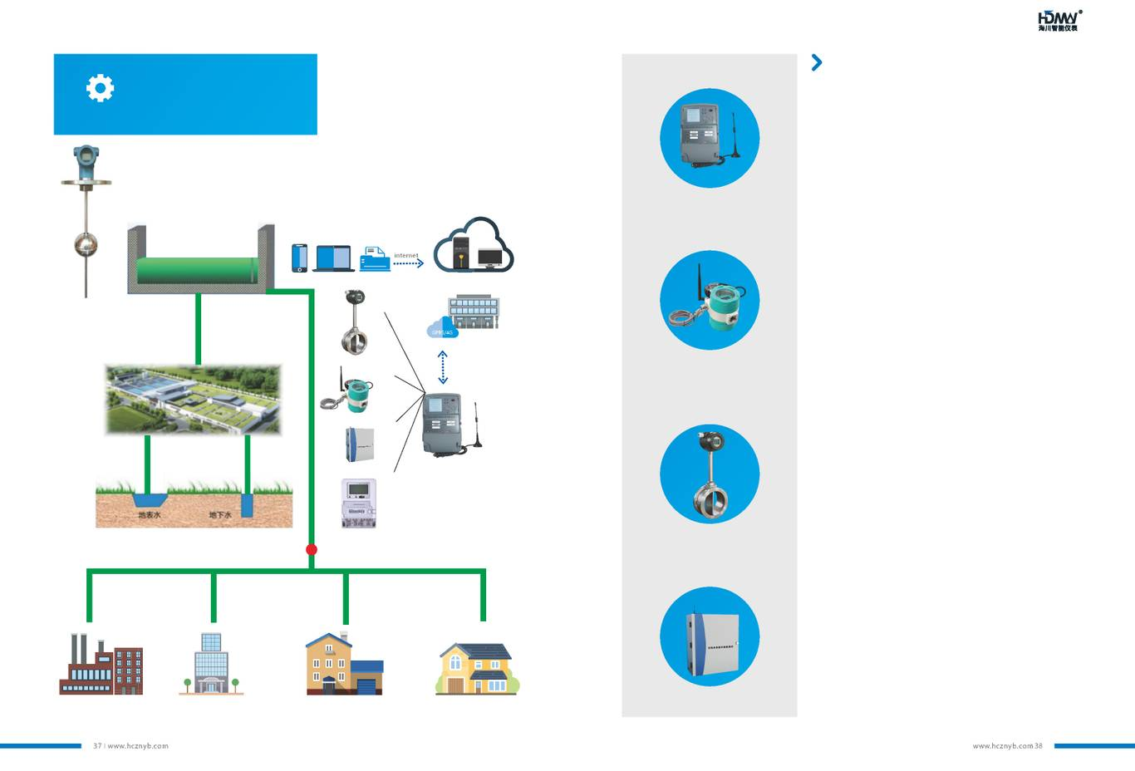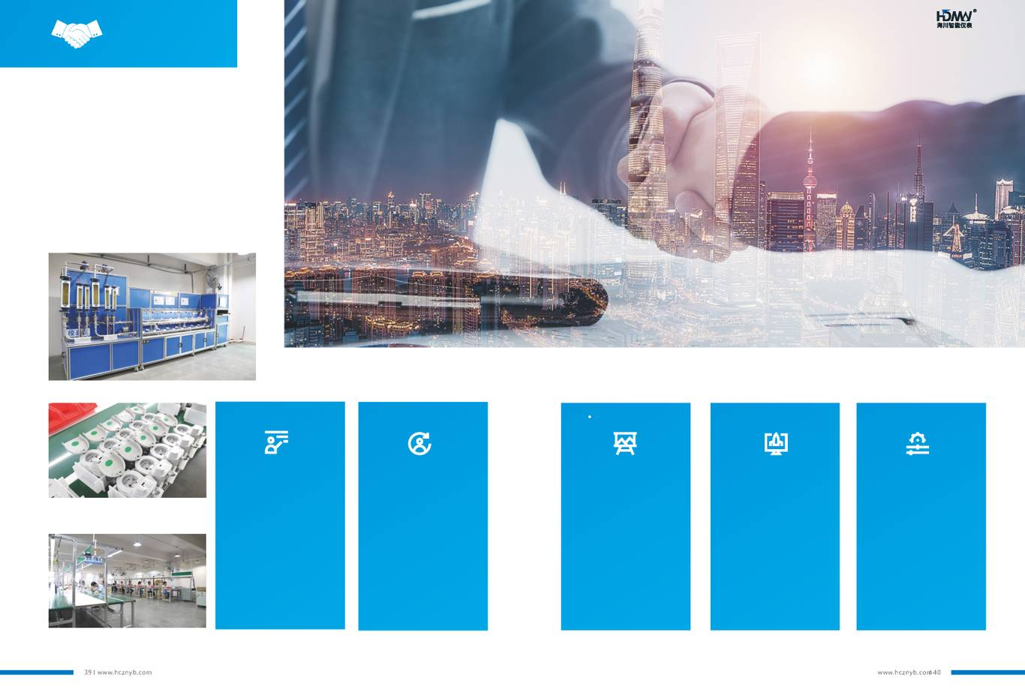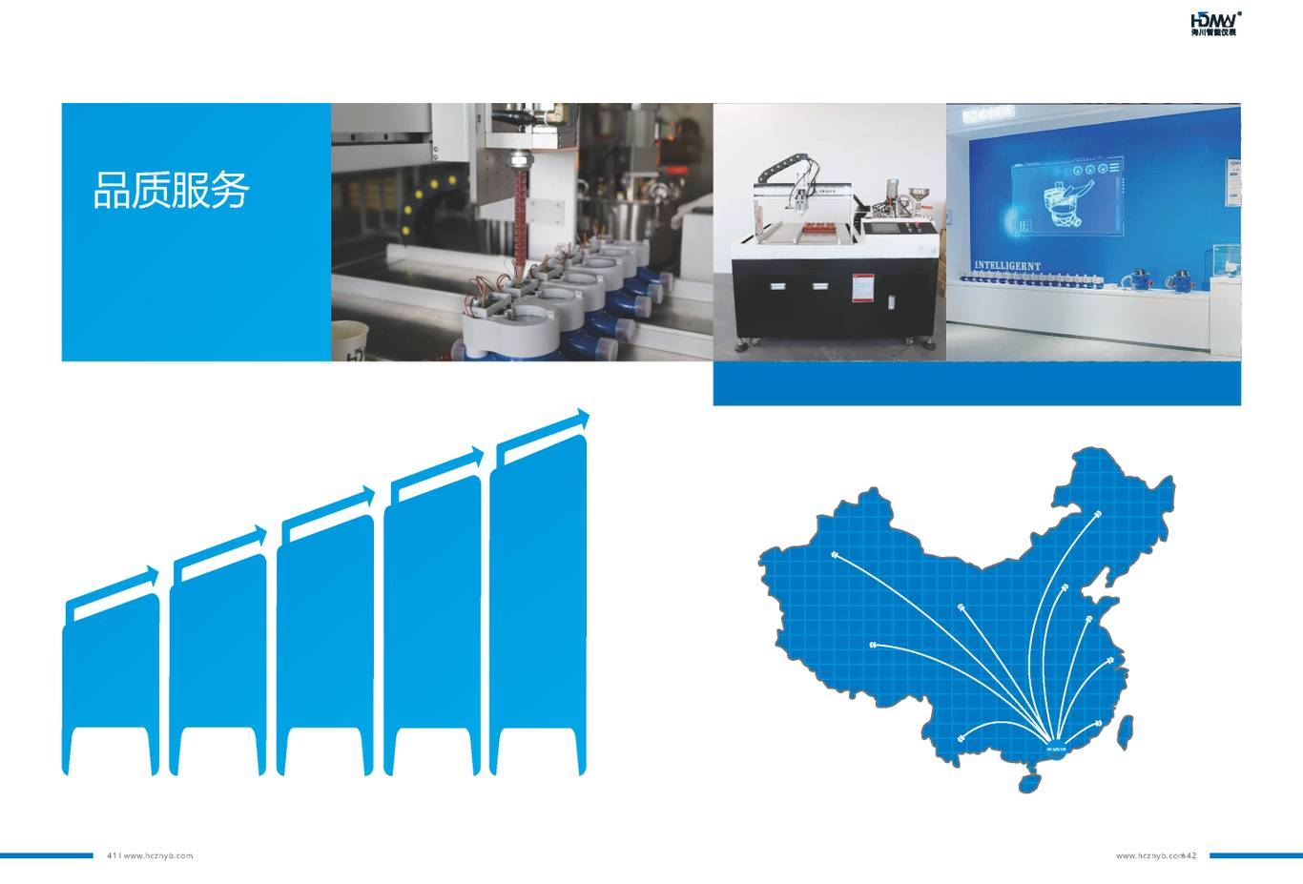
Foshan High Dream Intellectualized Meter Co., Ltd. Address: No.3 Longzhan Road, Huanglong, Beijiao, Shunde, Foshan, 528311, Guangdong China.
Tel: 0757-22393066 Fax: 0757-22393080
Email: highdream@126.com Official Website: www.hcznyb.com
High Dream Intellectualized Meter

Guangdong, China
From Every Stream, To Every Dream
Intelligent Meters: Professional and Focused, Embracing All Rivers to Lead Innovation
Contents
Contents
Group Introduction
Product Introduction
IoT Water Meter
Remote Transmission Water Meter
Prepaid Water Meter
Ultrasonic Smart Water Meter
Mechanical Water Meter
Smart Water Utilities
Supporting Equipment
Market Services

Group Introduction
Guangdong High Dream Intellectualized Machinery Co., Ltd.
Stock Code: 300720
120+
Countries around the world

50+
Domestic and International patents

70000+
M² plant area
450+
Well-trained employees

Development Goals

Ntegrity in business operations, provision of high-quality services, and continuous research and innovation. While comprehensively enhancing the industrial intelligent services of products, we will rely on the international management model, innovative business philosophy, and strong operational strength to strive to build into an international professional metering system.
Foshan High Dream Intellectualized Meter Co., Ltd.

Foshan High Dream Intellectualized Meter Co., Ltd. is a holding enterprise of Guangdong High Dream Intellectualized Machinery Co., Ltd. (Stock Code: 300720). It is a high-tech enterprise specializing in the research of industrial chains and standards related to the water industry, as well as the development, manufacturing, sales and service of its products. The main businesses include: LoT water meter , wireless remote transmission water meter , wired remote transmission water meter , prepaid water meter , ultrasonic intelligent water meter , mechanical water meter series, etc.; R&D, production, sales, consultation and technical services of intelligent meter reading terminals, computer software and system integration, etc.
The business covers the whole country and covering multiple aspects such as basic research and development, product development, marketing and sales, technical support, and education and training.Our services meet the inherent needs of several water utility companies in water - saving and safe water supply, and have been recognized.
Cooperation • Win-Win • Innovation • Development
Certificates
Honor and Qualification

Patent

Certification
Honor and Qualification
Patent
Certification
Remote Meter Reading System
Application Layer
Communication + Acquisition Layer
Mobile Terminal
Front-end Machine
Smart Water Cloud Platform
Customer Meter Reading Platform
UDP Direct Connection
Cloud Platform Push
Back-end Server
IoT Platform
NB/4G Base Station
IoT Water Meter
IoT Valve Water Meter
IoT Ultrasonic Water Meter
IoT Bulk Water Meter
(with Valve/without Valve)
(with Valve/without Valve)

IoT Water Meter Series
NB-IoT Water Meter
This series of smart remote transmission water meters developed based on NB-IoT communication technology. It features low power consumption, long-range communication, strong anti-interference capability, and stable data transmission.

Internal structure: it adopts a combination of ultra-low power consumption pulse sampling method and low-power NB-IoT transmission module.

External structure(A split design): the electronic unit is installed in an independent fully sealed cavity, with a waterproof performance of IP68 rating. It maintains the structure and accuracy of traditional wet-type water meters.
NB-IoT Water Meter (without Valve)
Product Features

· NB-IoT networking communication  · No additional centralized collection equipment required  · Each water meter is an independent terminal  · Convenient construction and installation, no wiring required  · Suitable for situations with dispersed meter installations. | · Communication is mainly affected by the signal of the operator's base station  · Meter reading data is actively reported, and control commands are issued remotely  · The number of reports and time can be freely set  · with Valve water meters can achieve prepayment when combined with the upper system  · Supports emergency valve opening function in emergency situations

Technical Parameters
Installation Dimension
Nominal Diameter (DN), mm
Permanent Flow Rate (Q3), m³/h
Measurement Range (Q3/Q1)
Metering Accuracy Class | Class 2
Max. Pressure
Pressure Loss
Working Temperature | Cold Water Meter (T30): 0.1℃~30℃ Hot Water Meter (T90): 0.1℃~90℃
Flow Profile Sensitivity
Communication Interface | Wireless: NB-IoT Infrared: 9600bps
Operating Frequency Band
Installation
Environmental Class | Class B
Electromagnetic Compatibility | Class E1
Waterproof Rating | IP 68
Working Voltage | 3.6V lithium battery, ER26500/ER34615
Case Material | Ductile Iron/Stainless Steel/Copper

DN15~DN25 (with Valve)) DN15~DN25 (without Valve))
Model | DN (mm) | L (mm) | L1 (mm) | H (mm) | W (mm) | Connecting Thread  d | Connecting Thread  D

NB-IoT Water Meter (with Valve)
NB-IoT Water Meter (Non-magnetic Sensing)
(with Valve/without Valve)

(with Valve/without Valve)

(with Valve/without Valve)

(with Valve/without Valve)
IoT Water Meter Series
4G IoT Water Meter
This is a new type of smart water meter that uses a Rotary Type Water Meter as its base.

Internal structure: Equipped with an integrated communication module and SIM card. 4G network enables direct transmission of water meter-collected data (flow rate, temperature, signal strength) to the meter reading system, achieving data collection, remote control, and fault alarm.

External structure(A split design): the electronic unit is installed in an independent fully sealed cavity, with a waterproof performance of IP68 rating. It maintains the structure and accuracy of traditional wet-type water meters.
4G Smart Water Meter (without Valve)
Product Features

· Mechanical & Electrical Design: Modular structure (mechanical & electronic parts), screw-assembled for easy maintenance.
· Network Coverage: NB & 4G hybrid, wide coverage for rural, urban, indoor scenarios.
· Communication: Direct base station connection, supports CT AEP, CM OneNET, UDP protocols.
· Measurement: Non-magnetic/magnetoresistive sampling, accuracy 1L/10L; The electronic section: equipped with bi-directional metering capability, synchronized with base meter to avoid disputes.
· Emergency Valve (Valve-controlled): Opens automatically in emergencies without network signal, maintaining water supply.
· Multiple modes of Data Reporting: daily, N times/day, every N days, specified dates; N≥2.
· Time-sharing Reporting: Prevents server congestion from a large number of simultaneous terminal reports.
· Abnormality Alarm: Alerts for power failure, sensor faults, valve faults.
· Prepaid Function (Valve-controlled): Enables back-end prepaid with upper system.
Technical Parameters
Installation Dimension
Nominal Diameter (DN), mm
Permanent Flow Rate (Q3), m³/h
Measurement Range (Q3/Q1)
Metering Accuracy Class | Class 2
Max. Pressure
Pressure Loss
Working Temperature | Cold Water Meter (T30): 0.1℃~30℃ Hot Water Meter (T90): 0.1℃~90℃
Flow Profile Sensitivity
Communication Interface | Wireless: 4G_Cat.1 Infrared: 9600bps
Operating Frequency Band
Installation
Environmental Class | Class O
Electromagnetic Compatibility | Class E1
Waterproof Rating | IP 68
Working Voltage | 3.6V Lithium Battery, ER26500/ER3461 5
Case Material | Ductile Iron/Stainless Steel/Copper

DN15~DN25 (with Valve) DN15~DN25 (without Valve)
Model | DN (mm) | L (mm) | L1 (mm) | H (mm) | W (mm) | Connecting Thread  d | Connecting Thread  D

4G Smart Water Meter (Non-magnetic Sensing)
4G Smart Water Meter (with Valve)
(with Valve/without Valve)

(with Valve/without Valve)

(with Valve/without Valve)

(with Valve/without Valve)

(with Valve/without Valve)

(with Valve/without Valve)

Direct Drinking Water Meter Series
IoT Direct Drinking Water Meter
This is a Smart water meter with Volumetric type and Rotary Type Water Meter as its base.
Internal structure: Equipped with an integrated communication module and SIM card.
4G network/NB-IoT enables direct transmission of water meter-collected data (flow rate, temperature, signal strength) to the meter reading system, achieving data collection, remote control, and fault alarm.
Product Features

· Strong anti-interference: Magnetoresistive sampling, 1L accuracy; The electronic section: equipped with bi-directional metering capability, synchronized with base meter to avoid disputes.
· Protection: IP68 rating, dual sealing (structural + potting) for excellent waterproof performance.
· Mech-Electrical Design: Modular (mechanical & electronic parts), screw-assembled for easy maintenance.
· Parameter Setting: Configurable via external infrared port and front-end system.
· Touch Wake-up Function: Activated by touch button or magnetic switch (≥3s), activate the trigger module to report data and infrared communication.
· Platform Communication: Supports AEP/OneNet transparent transmission, UDP direct connection, and CT/CM/CU thing models; fully compatible with IoT platform NB-IoT meters for seamless switching.
· Data Retransmission: Auto-retransmits failed data in next cycle; retransmission cycle and count configurable.
· Reporting Frequency: 4 modes (daily, multiple times/day, every multiple days, specified dates).
· Time-sharing Reporting: Prevents server congestion from a large number of simultaneous terminal reports.
· Emergency Valve (Valve-controlled): Opens automatically in emergencies without network signal, maintaining water supply.
· Overflow Valve Closing: Auto-closes when consumption exceeds set value; reopens manually to avoid waste from leakage or forgotten faucets.
Technical Parameters
Installation Dimension
Nominal Diameter (DN), mm
Permanent Flow Rate (Q3), m³/h
Measurement Range (Q3/Q1)
Metering Accuracy Class | Class 2
Max. Pressure
Pressure Loss
Working Temperature | Cold Water Meter (T30): 0.1℃~30℃ Hot Water Meter (T90): 0.1℃~90℃
Flow Profile Sensitivity
Communication Interface | Wireless: NB-IoT/4G_Cat.1 Infrared: 9600bps
Operating Frequency Band
Installation
Environmental Class | Class O
Electromagnetic Compatibility | Class E1
Waterproof Rating | IP 68
Working Voltage | 3.6V Lithium Battery, ER26500/ER3461 5
Case Material | Stainless Steel

DN15 (with Valve) DN8 (without Valve)
Model | DN (mm) | L (mm) | L1 (mm) | H (mm) | W (mm) | Connecting Thread  d | Connecting Thread  D

Direct Drinking Water Meter
（without Valve）
Prepaid Direct Drinking Water Meter
IoT Water Meter Series
IoT Water Meter (Bulk)
This is a new type of smart water meter that uses a Turbine Type Water Meter as its base.
Internal structure: Equipped with an integrated communication module and SIM card. 4G network/NB-IoT enables direct transmission of water meter-collected data (flow rate, temperature, signal strength) to the meter reading system, achieving data collection, remote control, and fault alarm.

External structure(A split design): The electronic device of woltman meters(DN40~DN200) can be fixed on the base meter or led out and installed on the wall. The whole machine has a waterproof performance of IP68, which maintains the structure and accuracy of traditional wet-type water meters.
Product Features

· Network Coverage: NB & 4G hybrid, wide coverage for rural, urban, indoor scenarios.
· Communication: Direct base station connection, supports CT AEP, CM OneNET, UDP protocols.
· Measurement: Non-magnetic/Hall sampling, accuracy 0.1m³/1m³; The electronic section: equipped with bi-directional metering capability, synchronized with base meter to avoid disputes.
· Data Reporting: Multiple modes (daily, N times/day, every N days, specified dates) (N≥2).
· Time-sharing Reporting: Prevents server congestion from a large number of simultaneous terminal reports.
· Abnormal Alarm: Alerts for power failure, sensor abnormality, disconnection.
· Battery & Application (DN40~DN200 Turbine type): Optional multi-section ER34615 battery packs, supporting intensive collection/reporting.
· Pressure Sensor (Vertical Turbine water meter): Optional installation.
Technical Parameters
Installation Dimension
Base Meter Type | Rotary Type |  | Turbine Type
Nominal Diameter (DN), mm
Permanent Flow Rate (Q3), m³/h
Measurement Range (Q3/Q1)
Max. Pressure
Pressure Loss
Working Temperature | Cold Water Meter (T30): 0.1℃~30℃ Hot Water Meter (T90): 0.1℃~90℃
Flow Profile Sensitivity
Communication Interface | Wireless: NB-IoT/4G_Cat.1 Infrared: 9600bps
Operating Frequency Band
Installation
Environmental Class | Class O
Electromagnetic Compatibility | Class E1
Waterproof Rating | IP 68
Working Voltage | 3.6V lithium battery, ER26500/ER34615
Case Material | Ductile Iron/Stainless Steel/Copper

(Rotary Type)
Woltman Meter (WPH)
Vertical Woltman Meter (WS)
Rotary Water Meter
(Turbine Type)
(DN) | L (mm) | H (mm) | W (mm) | Connecting Thread  d | Connecting Thread  D

DN (mm) | L (mm) | H (mm) | Flange Outer Diameter  D (mm) | Bolt Hole Center Circle Diameter  d (mm) | Connecting Bolt and Quantity
 |  |  | G1 1/2 (Thread Connection d) |  | G2B (Thread Connection D)

Remote Transmission Water Meter Series
Wireless Remote Water Meter
This is a remote water meter that uses Rotary Type Water Meter as its base.

Adopting LoRa communication technology, transmits data such as flow rate, battery voltage, and signal strength collected by the water meter to the meter reading system through a concentrator, achieving data collection, remote control, and fault alarm.

External structure(A split design): the electronic unit is installed in an independent fully sealed cavity, with a waterproof performance of IP68 rating. It maintains the structure and accuracy of traditional wet-type water meters.
Wireless Remote Transmission Water Meter (without Valve)
Product Features

· Double protection of structural sealing and potting glue sealing, with IP68
· Mechanical and electrical separation structure design for convenient later maintenance
· LoRa wireless communication technology, point-to-point networking mode, supports multi-level relay mode for meter end and repeater networking
· Fault alarm: supports low battery alarm/magnetic interference alarm/valve abnormality alarm
· The system can perform real-time meter reading and valve control without operation lag issues
· Open straight-line communication distance of 1km, which can be extended to about 5km through relay equipment
Technical Parameters
Installation Dimension
Nominal Diameter (DN), mm
Permanent Flow Rate (Q3), m³/h
Measurement Range (Q3/Q1)
Metering Accuracy Class | Class 2
Max. Pressure
Pressure Loss
Working Temperature | Cold Water Meter (T30): 0.1℃~30℃ Hot Water Meter (T90): 0.1℃~90℃
Flow Profile Sensitivity
Communication Method | Wireless: LoRa
Operating Frequency Band
Installation
Environmental Class | Class B
Electromagnetic Compatibility | Class E1
Waterproof Rating | IP 68
Working Voltage | 3.6V lithium battery, ER26500/ER34615
Case Material | Ductile Iron/Stainless Steel/Copper

DN15~DN25 (with Valve) DN15~DN25 (without Valve)
Model | DN (mm) | L (mm) | L1 (mm) | H (mm) | W (mm) | Connecting Thread  d | Connecting Thread  D

Wireless Remote Transmission Water Meter (with Valve)
(with Valve/without Valve)

(with Valve/without Valve)

(with Valve/without Valve)

(with Valve/without Valve)

(with Valve/without Valve)

(with Valve/without Valve)
Remote Transmission Water Meter Series
Wired Remote Water Meter
Photoelectric Direct-reading Wired Remote Water Meter uses electronic remote transmission technology to directly read character wheel data.

Compared with conventional pulse water meters, it can reduce reading errors to zero, making it an electronic remote transmission water meters with zero error in electromechanical conversion in automatic meter reading systems.

Moreover, it adopts a low-power design, requiring no power supply normally and only needing power supply during meter reading.
Product Features

•M-bus or RS485 communication  •Simple wiring, low cost, high meter reading success rate  •Zero electromechanical error: Optical character wheel recognition technology directly reads the water meter character wheel reading | •Meter reading is not affected by time, environment, or back-flow  •Bus current expansion power supply with strong load capacity  •Meter reading data supports active reporting and remote issuance of meter reading commands

Interface Parameters
Parameter Interface | Baud Rate | Protocol | Address Code | Dial Indication | Voltage
 |  |  |  | Last 8 Digits | Direct Current
Bus |  |  |  | Last 12 Digits
 |  |  |  | Last 12 Digits
Bus |  |  |  | Last 2 Digits

Technical Parameters
Installation Dimension
Base Meter Type | Rotary Type |  |  |  | Turbine Type
Nominal diameter (DN), mm
Permanent Flow Rate (Q3), m³/h
Measurement Range (Q3/Q1)
Max. Pressure
Pressure Loss
Working Temperature | Cold Water Meter (T30): 0.1℃~30℃ Hot Water Meter (T90): 0.1℃~90℃
Flow Profile Sensitivity | U10/D5
Communication Method | Wired: M-BUS/RS485
Communication Protocol | CJ/T188, DL/T645, Modbus (Optional)
Installation | H
Environmental Class | Class B
Electromagnetic Compatibility | Class E1
Waterproof Rating | IP 68
Working Voltage | RS485 interface: 7V-12V M-BUS interface: 24V~36V
Case Material | Ductile Iron/Copper

DN15~DN40 (Rotary Type)
Photoelectric Direct-reading Wired
Remote Water Meter (Small Diameter)
Photoelectric Direct-reading
Wired Remote Water Meter
(Woltman)
Photoelectric Direct-reading
Wired Remote Water Meter
(Vertical turbine)
DN40~DN200 (Turbine Type)
(DN) | L (mm) | H (mm) | W (mm) | Connecting Thread  d | Connecting Thread  D

DN (mm) | L (mm) | H (mm) | Flange Outer Diameter  D (mm) | Bolt Hole Center Circle Diameter  d (mm) | Connecting Bolt and Quantity
 |  |  | G1 1/2 (Thread Connection d) |  | G2B (Thread Connection D)

Note: (1) Communication distance: 300m; (2) Minimum data storage time: unlimited; (3) Communication protocol in accordance with the communication specification: CJ/T188-2004 Technical requirements of utility meters data transmission or as agreed by both parties; (4) No power supply normally; during data collection, 485 bus (0.6~0.8) mA, M-BUS bus (1.0~1.3) mA.
Prepaid Water Meter System
Server
Data Acquisition Layer
Perception Layer
Billing System Platform

Server
WIFI/4G/Ethernet
Online
Water Sales
Self-service Payment Terminal
IC Card
Bluetooth 4.0
IC Card Water Meter
Bluetooth Water Meter
IC Card
IC Card
IC Card Water Meter
IC Card Water Meter
Prepaid Water Meter Series
IC Card Smart Water Meter (Bluetooth)
IC Card Cold type Water Meter /IC Card Hot type Water Meter uses a Rotary Wet type Water Meter as its base.

Adopts the electromechanical conversion method of pulse magnetoresistive counting function, completes data transmission via IC card and Bluetooth, and is suitable for occasions where users have the requirement of mobile phone recharge for prepayment before water usage.
Product Features

· Can connect with mobile phone Bluetooth to realize meter setting, meter reading, and recharging  · Remote account opening, allowing users to realize non-card operation throughout the process  · Magnetic-sensitive one-way metering, which can prevent errors caused by jitter and self-rotation | · Valve Self-Maintenance, regular valve rotation removes scale, ensuring flexibility.  · Flexible setting of recharge limit to prevent users from hoarding water

Flow Parameters

DN (mm) | Measurement Range  Q3/Q1 Q2/Q1 | Overload Flow Rate  (Q4), m³/h | Permanent Flow Rate  (Q3), m³/h | Transitional Flow Rate  (Q2), m³/h | Minimum Flow Rate  (Q1), m³/h

Technical Parameters
Installation Dimension
Performance | Detailed Parameters
Power Supply | Lithium Manganese Battery 3.0 V, 6-year warranty, easy to replace
Display Method | Dual display with LCD and mechanical character wheel, LCD screen off in daily use, screen can be activated by card swiping and Bluetooth communication
LCD Display Content | Remaining Amount, Cumulative Consumption, Current Period Consumption, Valve Status (Valve Open/Valve Closed), Low Battery Indicator, Magnetic Attack Indicator
Data Collection Method | Pulse Magnetic Resistance, 10 L Position Signal
Medium Temperature | Cold Water Meter: 0.1℃~30℃; Hot Water Meter: 0.1℃~90℃
Storage Environment | Relative Humidity ≤ 90%
Pressure and Pressure Loss | Water Pressure ≤ 1MPa; Pressure Loss ≤ 0.063MPa
Level | Electromagnetic Environment: E1, Strong Magnetic Environment Prohibited;  Protection: IP68; Installation Environment: Class O
Bluetooth | Maximum Communication Distance in open space: 10m

IC Card Smart Water Meter (Bluetooth)
Horizontal
Bottom Inlet Vertical
Top Inlet Vertical
Model | DN(mm) | Control Dimension/mm (Copper)
Model | DN(mm) | Length L | Width B | Height H | Thread D | Thread d

Model | DN (mm) | Control Dimension/mm (Plastic)
Model | DN (mm) | Length L | Width B | Height H | Thread D | Thread d

Model | DN(mm) | Control Dimension/mm (Plastic)
Model | DN(mm) | Length L | Width B | Height H | Thread D | Thread d

Model | Nominal Diameter (mm) | Control Dimension/mm (Plastic)
Model | Nominal Diameter (mm) | Length L | Width B | Height H | Thread D | Thread d

Prepaid Water Meter Series
IC Card Smart Water Meter
IC Card Cold type Water Meter /IC Card Hot type Water Meter uses a Rotary Wet type Water Meter as its base.

Adopts the electromechanical conversion method of pulse magnetoresistive counting function, completes data transmission via IC card, and is suitable for occasions where users have the requirement of mobile phone recharge for prepayment before water usage.

Product Features

· HD LCD: shows purchased water volume, remaining volume, cumulative consumption, valve status, battery status, etc.
· Prepayment: Pay-first usage; auto-closes valve when out of credit, auto-opens after recharge.
· Mechanical and electrical separation design: convenient for maintenance in the later stage
· Prompt & Alarm: LCD prompts and valve-closing alarms for faults (battery power-off, under voltage, low water, strong magnetic interference).
· Valve Self-Maintenance: Regular valve rotation removes scale, ensuring flexibility.
· Water Price Setting: Supports single and stepped water price configuration at the meter end.
· IC Card Payment: Enables self-service payment via payment terminals.
· Bluetooth Function (Bluetooth Meters): Connects to mobile Bluetooth for meter setting, reading, and recharge.
· Protection: IP68 rating, dual sealing (structural + potting) for excellent waterproof performance.

Technical Parameters
Installation Dimension
Nominal Diameter (DN), mm
Permanent Flow Rate (Q3), m³/h
Measurement Range (Q3/Q1)
Metering Accuracy Class | Class 2
Max. Pressure
Pressure Loss
Working Temperature | Cold Water Meter (T30): 0.1℃~30℃ Hot Water Meter (T90): 0.1℃~90℃
Flow Profile Sensitivity
Communication Method | IC Card
Installation
Environmental Class | Class B
Electromagnetic Compatibility | Class E1
Waterproof Rating
Case Material | Copper

Model | DN (mm) | L (mm) | L1 (mm) | H (mm) | W (mm) | Connecting Thread  d | Connecting Thread  D

Ultrasonic Water Meter Series
Ultrasonic Water Meter
This is a new type of fully electronic water meter manufactured with industrial-grade electronic components. It detects the time difference caused by the change in speed when ultrasonic beams propagate downstream and upstream in water, analyzes and processes to obtain the water flow velocity and further calculates the water flow rate.

It has excellent small flow detection capability, micro power consumption, low starting flow, high stability, can solve many problems of conventional water meters.

Specifically used for household metering in residential communities, it meets the needs of water supply enterprises for accurate metering and settlement for end users, and has broad market and application prospects.
Product Features

· High measurement accuracy:Fluid stratified dual-channel/quad-channel measurement
· No mechanical rotating parts, no mechanical wear, good flow performance, small pressure loss, suitable for various water qualities
· Easy installation, with options for horizontal, vertical, and inclined installation
· Good anti-freezing performance
· Multiple transmission methods, supporting wired RS485 and wireless NB/4G transmission
· Double protection of structural sealing and potting glue sealing, with IP68
Technical Parameters
Flow Parameters
Nominal diameter (DN), mm
Permanent Flow Rate (Q3), m³/h
Measurement Range (Q3/Q1)
Max. Pressure
Pressure Loss
Working Temperature | Cold Water Meter (T30): 0.1℃~30℃; Hot Water Meter (T90): 0.1℃~90℃
Flow Profile Sensitivity | U5/D3
Communication Method | Wireless: NB-IoT/4G_Cat.1; Wired: RS485; Infrared: 9600bps
Communication Protocol | Wireless: internal protocol, customizable development;  RS485 interface: CJ/T188, DL/T645, Modbus (optional)
Power Supply Method | Built-in battery power supply (default); External power supply: 7V~12V (customized)
Installation | H/V
Environmental Class | Class O
Electromagnetic Compatibility | Class E1
Waterproof Rating | IP 68
Case Material | Stainless Steel/Carbon Steel/Copper

4G Ultrasonic Water Meter
(Small diameter)
NB-IoT Ultrasonic Water Meter
Wireless Remote Bulk Ultrasonic Water Meter
DN(mm) | L (mm) | H (mm) | W (mm) | Connecting Thread  d | Connecting Thread  D

DN (mm) | Overall Dimensions |  |  |  | Minimum Starting Flow |  |  |  |  | Weight  kg | Max. Pressure  MPa
DN (mm) |  |  |  |  |  |  | Bolt Hole Diameter × Quantity | Sealing Surface | Flange Thickness C | Weight  kg | Max. Pressure  MPa

Mechanical Water Meter Series
Mechanical Water Meter
Rotary Type Cold Water Meter/Turbine Type Cold Water Meter are specialized instrument suitable for measuring the total volume of water flowing through tap water pipes.

It has characteristics such as high sensitivity, accurate measurement, small head loss, durability, and convenient reading.
Product Features

· Performance requirements meet the GB/T 778.1~3-2018 standard
· Featuring compact structure, high metering accuracy, small starting flow, reliable operation, etc.
· Special wear-resistant materials, processed with error trend gradually corrected, to avoid water fee loss
· Check valve can be installed as needed to prevent water back-flow
· Can reserved magnetic or non-magnetic signal pointers. Configured with various remote transmission devices according to different requirements.
Technical Parameters
Installation Dimension
Base Meter Type | Rotary Type |  |  |  | Turbine Type
Nominal Diameter (DN), mm
Permanent Flow Rate (Q3), m³/h
Measurement Range (Q3/Q1)
Max. Pressure
Pressure Loss
Working Temperature | Cold Water Meter (T3O): 0.1℃~30℃ Hot Water Meter (T90): 0.1℃~90℃
Flow Profile Sensitivity
Installation
Environmental Class | Class B
Electromagnetic Compatibility | Class E1
Case Material | Ductile Iron

Rotary Water Meter
Vertical Turbine Water Meter
Woltman Meter
DN (mm) | L (mm) | H (mm) | Flange Outer Diameter  D (mm) | Bolt Hole Center Circle Diameter  d (mm) | Connecting Bolt and Quantity
 |  |  | G1 1/2 (Thread Connection d) |  | G2B (Thread Connection D)

DN (mm) | L1 (mm) | H (mm) | W (mm) | Connecting Thread  d | Connecting Thread  D

DN40~200 (Turbine Type)

DN15~40 (Rotary Type)
Project Overview
Integrated Smart Water Solution
We integrate cloud computing, big data, GIS geographic information, and IoT technologies, conduct in-depth water supply data modeling, pipeline network spatial and hydraulic models to create a customized integrated management platform for water utilities.(water production - water supply - user water consumption)

we assist water utilities in operation and maintenance management in a refined, dynamic, and "intelligent" manner.. Thereby ensuring reliable water supply, reducing leakage and narrowing the production and sales difference, enhancing operational control capabilities.
Smart Marketing
Smart Pipe Network
Big Data of Water Management
DMA Partition
Smart Water Plant
Smart Marketing
Smart Pipe Network
Smart Water Plant
iWater APP
Data Acquisition Platform
Data Synchronization Engine
Ethernet
Application Layer
Data Warehouse
Transport Layer
Perception Layer
Layered Structure
Data Acquisition Platform
Open Multi-vendor Compatibility
The platform has considered compatibility with the access of third-party manufacturers' equipment, and does not set any thresholds for third-party manufacturers' access.
Supports Various Devices
For residential: mechanical water meters, wireless/wired remote transmission water meters

For industrial/commercial : NB-IoT water meters, large-diameter water meters for pipe networks, pressure gauges, flow meters and other pipe network equipment
Supports Multiple Communication Methods
Serial Port, Ethernet, 4G, LoRa, NB-IoT
Platform Features
Diversified Meter Reading Strategies
Can be set with daily, weekly, monthly, single or multiple times meter reading strategies, with active upload.
Supports connections for up to one million devices.
Ensures data collection stability at the scale of over one million devices. Features a collection service cluster and dynamic service balancing, enabling horizontal scalability of the cluster service to be virtually limitless.

Third-party Data Interface
Provides diverse formats and interfaces to facilitate data import and export for third-party systems.
Smart Marketing
Fee Collection and Account Settlement
- Supports multi-channel fee collection ,including: counter, bank, Alipay, and WeChat
- 24-hour service
- Supports paper and electronic invoices
- Supports IC card water meters, mechanical water meters, remote transmission water meters, etc.(One-Stop Solution)
Household Registration and Installation Application
- Supports applying for services on mobile devices.
- Full-process tracking and progress reminders
- Supports approval on mobile devices.
- Customizable processes and forms
Meter Reading Management
- Diversified Water Consumption Data Collection Methods
- SMS Payment Reminder
- Remote Valve Switching
- Automatic Valve Closure for Arrears
- Automatic Valve Opening Upon Payment
- Support Water Fee Daily/Monthly Settlement
Statistical Analysis
- Abnormal Water Usage Analysis
- Meter Reading Rate Statistics
- Payment Collection Rate Statistics
- Monthly and Annual Water Usage Situation Analysis
- Revenue Statistical Report
Smart Marketing
By adopting a B/S (Browser/Server) architecture, a cloud-based service model is implemented to rapidly develop a comprehensive marketing management system for small-scale water utilities. This integrated system includes functionalities such as customer profiling, meter reading management, account management, and statistical reporting, all designed to boost the marketing efficiency and operational analysis capabilities of water utilities.
iWater APP
Based on mobile Internet technology as the basic architecture, it integrates relevant businesses of the water company, applies mobile APP technology to change the conventional business model, and enables staff to handle daily business more conveniently and quickly using the APP.
Mechanical Water Meter Reading
Read the mechanical water meter according to the meter reading book and meter reading path, upload to the server.
Supports online/offline meter reading.
Remote Valve Control
Perform real-time valve opening and closing control for remote transmission water meters via mobile phone.
Mobile Office
Initiates work processes and process workflows, and tracks process progress anytime and anywhere.
Business Management
Management personnel can conveniently and quickly view annual and monthly business data.
DMA Partition Metering
Smart Pipe Network
One Map (Pipeline Network GIS)
The pipeline network direction, valves, large meters, flow meters, pressure points, and waterworks are fully digitized, displayed on a visual map, and never lost.

Pipe Burst Analysis
Simulate pipe burst points, analyze the valves that need to be closed, affected pipelines, and affected users, providing a basis for decision-making.

Hydraulic Model
Analysis of pipeline network node pressure and instantaneous flow provides more scientific and effective auxiliary design support for the design and construction of water supply pipelines.

Water Cut-off Area Analysis
Based on spatial operations and valve closure plans, analyze the areas that will have water cut-offs due to accidents, and notify water users in the water cut-off areas via SMS.

Pipeline Network Monitoring
Monitoring of pipeline network flow and pressure, data analysis, flow and pressure curves, providing data support for water supply operation and maintenance management.
The pipe network is divided into regionalized and grid-based management areas. According to the service area and length of the pipe network, the water supply area can be divided into multiple metered areas (DMA). Using modern wireless communication technology, real-time transmission of data such as flow, pressure, and water quality is carried out, so that the operation status of the pipe network in each metering area can be timely and accurately grasped, providing a scientific basis for optimizing the water supply pipe network.
Production and Sales Difference Analysis
Identify real leakage, normal leakage, and management leakage to provide a basis for pipe network optimization and management improvement.

Night Minimum Flow Analysis
The system can set the baseline value of the minimum night flow for partitions, analyze partitions to evaluate night water usage categories, sudden water usage, or new water leakage. And it can issue alarm information according to the set water leakage threshold and evaluate the economy of repairing new leakage.
Big Data of Water Management
Smart Water Plant
Integrated visual large-screen display system of the leadership cockpit and water dispatch center.
Can refresh equipment operation data at various key points in the pipe network and water plants in real time and dynamically; through big data analysis, all key data can be mastered on one screen.
Real-time Monitoring and Alarm for Pump Room Equipment
Filter Tank Water Level, Turbidity, and Equipment Monitoring Alarm
Real-time Monitoring and Alarm of Dosing Equipment
Various Production Data Reports
Supporting Equipment
Water Tank Liquid Level
Liquid Level Meter
Factory Water Supply
Commercial Water Supply
Residential Area Water Supply
School Water Supply
Adjustable Valve-Size
Smart Electric Meter
HCG-L/M Type Data Concentrator
Water Quality Analyzer
Pressure Analyzer
Flow Meter
Server Monitoring Display
Mobile APP Client Printer
HCG-L/M
Data Concentrator
Pressure Analyzer
Flow Meter
Water Quality Analyzer
Product Features
Data Collection and Processing Function
Can perform real-time polling or automatically collect relevant data information of remote transmission meters according to the set reading interval;

Timed Automatic Collection
The concentrator automatically collects data from remote transmission meters according to the meter reading plan set by the master station;

Setting Function
Can set automatic meter reading cycle, reading interval, reading interval, etc., and measures to prevent unauthorized personnel from operating;

Expansion Function
Can receive commands from the control center or freeze the cumulative amount of water, gas, and heat meters at a specified real-time time according to the set freezing time;

- NB-IoT network is applicable in a wide range of regions;
- LCD real-time display;
- Antenna types available: external and integrated; external antenna can be selected for areas with weak signals;
- Built-in low-power circuit and 28000mAh large-capacity lithium battery, can work continuously for more than 6 years in areas with stable signals (considering appropriate reporting frequency);
- Upper and lower threshold alarm function;
- Automatic time calibration when connected to the network, automatic reconnection when disconnected;
- Supports trigger operation, and the instrument can be configured on-site;
- Web terminal for viewing and remote configuration of the instrument, supporting data query via mobile phone SMS;
- With shockproof and moisture-proof functions, suitable for field environments;
- Different process connection interfaces can be customized according to customer needs;
- OEM customization of products with different protocols is available.

- Can measure the volume flow and mass flow of steam, gas, and liquid.
- Sensor can be installed and removed without stopping the flow; amplifier and sensor can be separated (separation distance 15m).
- Adopts anti-interference circuit and anti-vibration sensor head, enabling the instrument to have certain resistance to environmental vibration.
- Low pressure loss, wide measuring range, with a range ratio of 10~40 times.
- No mechanical moving parts, long-term stability, simple structure for easy installation and maintenance.
- Measurable medium temperature up to +350℃ (+450℃).

- Modular design, each measurement parameter can be freely combined and flexibly configured;
- Supports the determination of pH, conductivity/TDS, turbidity, residual chlorine/total chlorine, and temperature;
- Supports two measurement modes: continuous measurement and periodic measurement;
- Supports automatic cleaning function;
- Equipped with five electromagnetic relays, supporting external device control;
- Equipped with RS-485 digital interface, supporting data export and remote communication (wired or wireless);
- IP65 protection class.
- Optional color touch screen control panel for on-site data display and control.
- Optional solar panel for outdoor power supply.
Monitoring Center
Market Services
Quality Assurance
Comprehensive Quality Management System Service Guarantee

During the warranty, we are responsible for free repair, replacement, and accuracy verification of measuring devices, and is also responsible for lifetime maintenance.

We are responsible for the training of management personnel free of charge, and the time and place shall be determined by the purchaser. Before installation, we conduct training on on-site installation and commissioning precautions; after installation, conduct training on usage and operation, etc.

During the installation process, we provide on-site guidance services to ensure the normal installation and use of the meters.
Customer First,

Your needs set our roadmap; your feedback drives our next upgrade.
From first hello to lifetime support, every step is shaped around you.
Full Participation

All employees are quality inspectors, participating in the entire process from product design, raw material procurement to product shipment. They identify and report issues to ensure product quality and enable the company to continuously improve product quality throughout this process.
Process Planning

Effectively control and manage the entire process from market research, development and design, production manufacturing to sales and service, ensuring product quality and customer satisfaction.
Process Management

Establishes a full-process quality assurance system covering product research and design, production and manufacturing, after-sales service and other activities. And produce products that satisfy users with the most economical means.
Process Improvement

The PDCA (Plan-Do-Check-Act) cycle-based quality management approach.
请将这里的中国地图改成：世界地图
Quality Service
24/7 hours service hotline Quick response within 2 hours on-site service within 48 hours
Equipped with professional maintenance personnel, 24/7 hours service for customers
Equipped with senior technical personnel to explain the precautions for customers at the user end
Equipped with senior industry marketing personnel to provide you with the highest quality product recommendations and solution formulation
Implement lifetime maintenance for our company's products
Regardless of the cause of product failure, we will reply within 2 hours upon receiving feedback information
Professional Maintenance Team Support
Systematic Technical Training
Solid On-site Service
Lifetime Maintenance
Timely Handling
Professional After-sales Team Covers the Globe

